**Assignment # 2**

**Due date: 19-05-17**

**Total 20 Marks**

**Q#1.** Suppose you have data file of the following text “***You are my favorite Teacher***” and you wants to encode it and your objective is to develop a code that represents a given text as compactly as possible.

Construct a tree using Huffman codding and assigned the code to each character including “blank space” and Find that how many bits are saved by using Huffman codding approach instead of using fixed length code. **10 Marks**

**Q#2.**Apply Prim’s Algorithm on the following graph to find the Minimum spanning tree **10 Marks**

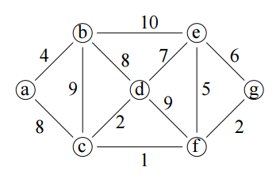

**Note:**

* Any student found cheating in any of the two assignments submitted will be awarded zero marks in the assignment
* No assignment after due date will be accepted.